L2 or L3 or tests name: Annual and ongoing risk taker analysis
Legal entities in scope: CBL/ECAG/CBF/CH/LuxCSD
Test(s) according to RCA:
Control design effectiveness
1.Review the process in place to identify key process steps and controls.
2.Validate that the process is in line with regulatory requirements.

Control operating effectiveness
1.On a sample basis, validate that:
-risk taker analysis documentation is complete
-relevant approvals are obtained
-controls were executed and documented

Risk:
Incorrect capturing of risk taker Mistakes in the ongoing risk taker analysis can lead to a written comment from the regulator. It must be seen as entity level risk.
Due to human error, inadequate review and interpretation of existing information for Annual Risk Taker Analysis resulting in wrong Risk Taker Identification.
Inadequate review and interpretation of existing regulations and changes, resulting in incorrect implementation/ application of these for Annual Risk Taker Analysis.
Risk Taker process is not compliant with major applicable regulatory requirements leading to severe findings

Conclusion: OK, no issues for CoL.
1 Audit Comment: Potential for SAP Success Factors tool enhancement

Audit procedures/source:
Internal audit (PP) has performed the following Audit procedures:
- Inquiry: Held interviews with responsible stakeholders
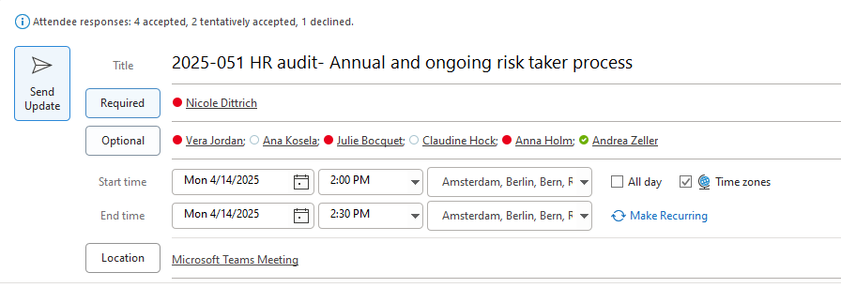
- Inspection: Of policies and evidence
- Sampling for annual risk taker assessment for CBL, CBF, CH, LuxCSD and ECAG (as legal entities applicable for the process)

Procedures / Criteria / documents used
- Annual Risk Taker Analysis
- Ongoing Risk Taker Analysis
- Commission Delegated Regulation (EU) 2021/923

Work Done:
Control Design Effectiveness
1.Review the process in place to identify key process steps and controls.

Two procedures in place describing the key controls and steps:
Ongoing Risk taker analysis
Annual risk taker analysis

Trigger events for the ongoing risk taker review are new hiring, promotions, structural changes.
For the annual risk taker review: Organization and conduction of a joint meeting with LE’s Compensation Officer and control functions (Risk Management, Compliance) for yearly alignment on methodology of Risk Taker Analysis with the business and risk strategies as well as regulatory requirements. In addition, the outsourcing relationship is taken into account.

IA inquired about the following:
- Is a change in the outsourcing relationship a trigger similar to the annual risk taker analysis
- If yes, how does outsourcing provide information about a change
Refer to minutes from inquired here

Results: OK, no issues noted. However, the input in SuccessFactors does not require a 4EP. This was due to the functionality of SF. Please refer to Audit Comment: Potential for SAP Success Factors tool enhancement

2.Validate that the process is in line with regulatory requirements.

The following regulatory requirements have been identified:

Commission Delegated Regulation (EU) 2021/923 outlines both qualitative and quantitative criteria for identifying material risk-takers within credit institutions:
Qualitative Criteria
Staff members are identified as material risk-takers if they:
- Hold managerial responsibilities or control functions.
- Are responsible for groups of staff whose activities could significantly impact the institution's risk profile.
- Have authority to commit the institution to significant credit risk exposures.
- Are involved in decision-making processes that affect the institution's risk profile.

Quantitative Criteria
Staff members are identified as material risk-takers if they:
- Have total remuneration of EUR 500,000 or more per year.
- Are among the 0.3% of staff with the highest remuneration, provided the institution has more than 1,000 staff members
- Receive remuneration that is equal to or greater than the lowest remuneration of senior management or other risk-takers

These are noted in the Annual risk taker analysis procedure.

Results: OK
The control design is assessed as effective

Work Done:
Control Operating Effectiveness
1.On a sample basis, validate that:
-risk taker analysis documentation is complete
-relevant approvals are obtained
-controls were executed and documented

Based on a risk based approach, IA selected to test the annal risk taker analysis.

IA obtained for each legal entity that has the risk taker process in place (CBF, CBL, CH, ECAG and LuxCSD), the presentation to the ExBo of each LE and the final agreement.

Refer to the respective folders for evidence:
CBF
CBL
CH
ECAG
LuxCSD

Results: OK
The control operating effectiveness is assessed as effective

